Planning Developmentally Appropriate Math Experiences for Children

By: Stephanie Daniel, Ed.D.
“Pure mathematics is, in its way, the poetry of logical ideas.” – Albert Einstein

Learning Objectives
- Describe strategies used in planning developmentally appropriate math activities for young children birth to age eight.
- Identify key concepts of numbers.
- List goals and objectives for number activities.
- Describe approaches teachers can use to document and assess children’s learning of math concept – number and number operations.
- Describe ways to build partnerships between home and school.
- Write a lesson plan including all the necessary components.

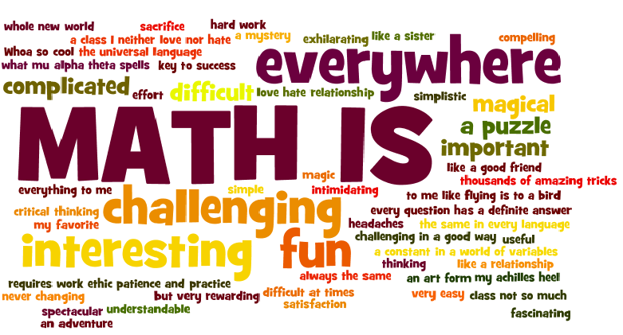
Introduction
Math is used daily as we count the coins the cashier gives us back after purchasing lunch. We keep track of our daily schedule because of the math skills we learned when we were younger. We recognize shapes and patterns all around use because of teachers like you who spent hours planning meaningful learning experiences to support and guide our understanding of various math concepts. Now, it’s your turn to explore the meaning of math and your role as an early childhood teacher, who is responsible for planning meaningful math lessons and activities for young children in your early childhood classroom.
To further our understanding and appreciation of math, we will begin by defining the term. According to Herr (2012), math is sometimes defined as the science of numbers and shapes. It involves thinking, and for children to become mathematical thinkers they need time to solve problems and reasoning – draw logical conclusion – about numbers and operations (Bredekamp, 2014). As we explore the math concept of numbers and number operations, we will examine the role of the teacher.
According to Bredekamp (2014) teaching mathematics involves several key elements. First, teachers must know and understand the concept of math. Second, teachers must know what math processes and content children need to learn and when they should be taught. Third, teachers must know how to promote “whole child” development, specifically the cognitive developmental domain. Lastly, teachers must know how to plan and implement effective teaching strategies (module four) that promote both cognitive and math skills in young children (Bredekamp, 2014). Now, let’s put this in perspective by learning more about promoting the math concept – numbers and number operations.

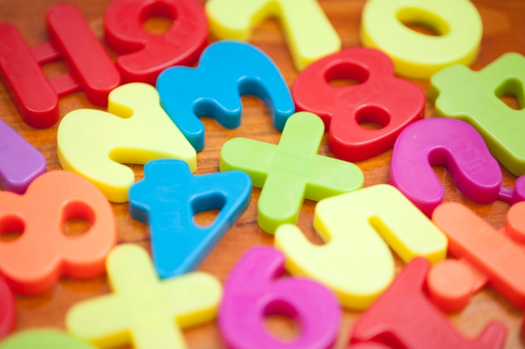
Mathematics – Numbers and Number Operations
When teaching young children about numbers, cognitive skills are needed. For example, if a teacher is writing a developmental goal, she would state “Children will compare numbers, count numbers, and recognize quantities” (ELDS, 2021). Another developmental goal focus on children understanding number relationships and solving problems using operations (ELDS, 2021). Considering these two goals, children must have daily experiences where they compare and count numbers in ways that are meaningful and challenging at the same time (Foundation Blocks, 2013, p. 11). An example of such an experience involves children interacting with items they encounter daily. Take my daughter’s barrettes. I used these every day to put on her hair. While combing her hair, my daughter would count the number of blue barrettes on the bed. Then she would count the number of red barrettes. As she is counting the barrettes, my question to her is “How many blue barrettes do you have? When she states “Six, mommy!” I observe her ability to count and recognize quantity. This could also be a way to assess her understanding of ELDS standard area five cognitive development and mathematics counting numbers and recognizing quantities. After mastering these two concepts, we could say at this point she understands rote counting because she is able to now tell me how many objects she has after she has counted the barrettes. Let’s example counting more in-depth.
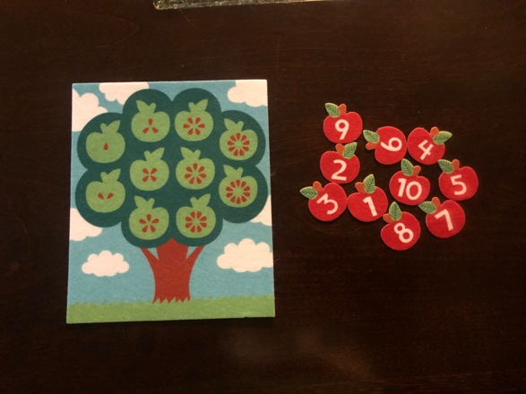
Learning the basics of counting can be done by using items that children are familiar with. For example, counting “Cheerios” or “Apple Slices” can help children recognize that the number counted represents the number of “Cheerios” or “Apple Slices” they have in their bowl. Using these items allow children to make a connection between the real world and the math skills that contribute to their future academic understanding and success.
The first stage of counting is rote counting. This skill is the first skill learned when teaching children about numbers. Partly, because they love to recite numbers while engaged in daily play experiences. According to Bredekamp (2014), children memorize the sequence of numbers by playfully repeating them over and over, the same way they learn the alphabet sequence by singing the alphabet song long before the letters are fully meaningful (p. 419). Therefore, teachers should constantly encourage children to explore counting. For instance, placing teddy bear counters on the table is an opportunity for children to rote count. Another example is inviting toddlers to count their fingers. There are many simple activities that teachers can plan to encourage simple rote counting.
Rational counting is the next stage. According to Herr (2012), children should always be exposed to rational counting using concrete objects (p. 572). For example, using those same teddy bear counters the teacher can place them in a straight line. Then model counting the teddy bears for the children. As you are counting, encourage the children to point to or touch each bear as they are counting. Keep in mind for children to grasp this concept, lots of counting experiences is essential (Herr, 2012).
Next, one-to-one correspondence is the foundation for understanding counting. It is the most basic part of the numbers concept, and there are many activities teachers and parents can plan to help children understand this concept. According to Herr (2012), one-to-one correspondence is the understanding that one group has the same number as another (p. 572). An example of one-to-one correspondence can be seen during sociodramatic play. According to Bredekamp (2014), sociodramatic play provides a context for children to use their developing math skills (p. 432). For instance, while playing restaurant, children use one-to-one correspondence as they set the table for the customers.
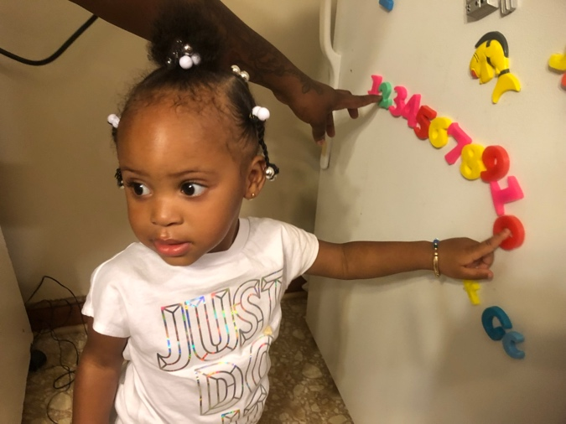
Lastly, as early childhood teachers, we want to teach children how to recognize numerals. According to Herr (2012), children must be exposed to numerals to gain recognition skills. For example, numerals can be seen everywhere. Bullard (2014), recommends allowing children to explore calculators, adding machines, playing cards, magnetic numbers, and puzzles which are developmentally appropriate materials to help children recognize numerals. The more children are exposed to numerals, the more they begin to understand and can recognize them. Think about these two questions: What are some materials you could add to your math center to help children with recognizing numerals? How can you help children learn how to write numerals? Answering these two questions, helps teachers plan developmentally appropriate math activities which is essential because it ensures activities planned meet children’s individual needs and learning styles. Now let’s dive deeper into planning developmentally appropriate math activities.

Planning Developmentally Appropriate Math Activities
There are many lessons and activities teachers can plan that are developmentally appropriate. Through games, lessons, activities that involve numbers and number operations, teachers can foster children’s understanding of this math concept daily using everyday routines. The idea is to begin with determining developmental goals, asking “why” questions to help teachers think through the benefits of completing the game, lesson, activity, or routine.
- Why am I teaching this lesson or planning this activity?
- Why is it important that the children learn this concept or skill?
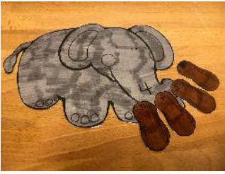
As teachers think through these questions, they begin to consider goals they want to establish for the children to accomplish. Take the “Circus Animals” theme. The teacher plans an “Elephants” lesson. The goal of this activity is for children to: (1) Identify numbers on the elephant (Recognizing numerals) and (2) count the correct number of peanuts to match the number on the elephants (rational). Next, the learning objectives are outlined. These include an outcome description of the activity, used to plan teaching strategies (module four), and are broken down into three parts: (1) Condition of performance, (2) Behavior, and (3) Level of performance. Each play an important role in what the teacher wants the children to learn by completing the lesson.
Considering the “Circus Animal – elephants” lesson again, there are two learning objectives for this activity. Learning objective one: Using elephants with numbers on them (condition of performance), the children will say (Behavior), the number on the elephant. Learning objective two; When asked (Condition of performance), the children will count (Behavior), the correct number of peanuts to match the number on the elephant (Level of performance).
As we can see, the developmental goals and learning objectives are aligned. After the developmental goals and learning objectives, we outline how the activity will be introduced, materials needed to complete the activity, and a step-by-step summary of the lesson. Next, we have the closure and transition, evaluation, and enrichment components of the lesson. Each of these components and a few others not mentioned will be discussed when we practice writing our own math lesson plan. Again, we will discuss teaching strategies that could support and guide our planned math lessons and activities.

Teaching Strategies
Teaching strategies are principles and methods used to teach children. To further explain, strategies are the way teachers choose to provide information and facilitate the learning experiences. For early childhood classrooms, this looks like a balance between teacher-directed and child-centered activities planned throughout the day. It also includes differentiated instruction, which simply means tailored experiences to meet children’s individual needs and learning styles (Tomlinson, 2022). In module four, there were a few teaching strategies discuss. In this module, additional teaching strategies to support math learning include repetition, group work, manipulation tools, and math games. Repetition is a great strategy that allow children to practice and repeat numbers throughout the day. The more they repeat a skill, the better they become at the skill. For example, simply counting one thru 10 each day during circle time is a form of repetition, and a great way for children to memorize numbers while also exploring rote counting. During this time, the teacher could also show the actual numeral why the children are saying it. This will help them recognize the numerals as they say them.
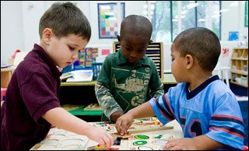
Group work whether large or small is another great opportunity for children to practice the counting and recognizing numerals. For example, planning a small group matching game or number BINGO are great ways for children to work and learn together. Another learning experience to support children’s math learning is doing a number chant. During circle time, have children say their numbers one at a time. You start with the number one, the child beside you say “two,” the next child says “three,” and so on. This goes on until you get to a designated number, or until you start to lose the children’s interest in the activity. I remember observing a teacher doing this with her pre-K class. I thought it was a great way for them to count as a large group.
There are a ton of manipulation tools to include in your classroom for children to explore when it comes to promoting the math concept – numbers and number operations. According to Herr (2012) collection of items for counting, observing, creating, and comparing should be included in your classroom (p. 564). As teachers select materials to include in this collection, considering the appropriateness of materials is important. Materials should allow for active manipulation, have a clearly defined mathematical purpose, and are open-ended or self-correcting (Bredekamp, 2014). The last teaching strategy is math games. These should promote the development of many skills, to include the developmental domains discussed in module one. As an early childhood teacher, you want to plan activities and games that promote growth in these areas (i.e., physical, cognitive, social – emotional, language). Moreover, these games and activities you choose as an early childhood teacher will be based upon the developmental readiness and interests of the children (Bredekamp, 2014) in our classroom. After planning and implementing these learning experiences, teachers must also think about how they will assess and document children’s learning.

Assessing and documenting children’s learning
There are many methods teachers can use to assess children’s learning when it comes to math. The following ideas are just a few methods that can be used to assess and evaluate children’s understanding of math concept – numbers and number operations. For instance, planned activities, a portfolio to store children’s work, and specific tasks.
To illustrate, through planned activities and specific tasks, teachers can observe children to determine their strengths and weaknesses. For instance, while observing a child during a planned activity that involves them participating in a counting game using teddy bear counters, the teacher can listen as the child is counting to ensure he or she is counting in the correct sequence – not missing any numbers (Bullard, 2014). If the teacher notice that a child cannot count using the correct sequence, this is an opportunity to jot down notes that will assist in planning additional activities that can be used to support the child’s continuous learning.
We know the benefits of using a portfolio to store children’s work. Here is where teachers can store all the activities completed that document the child’s math learning. For instance, a planned activity that involves the child counting out pompoms to glue on their yellow piece of construction paper. As they count out the number of pompoms they are going to glue to their paper, the teacher can write the corresponding numeral to match, if the child isn’t able to write the numeral themselves. The teacher can also take pictures of the child during the learning process to include in his or her portfolio. After the child has glued all their pompoms, another way the teacher could assess their understanding is to ask, “how many pompoms do you have on your paper?” After the child has counted, he or she will state the numeral (mastered the concept) or not, either way, the teacher must document the outcome for future curriculum planning.
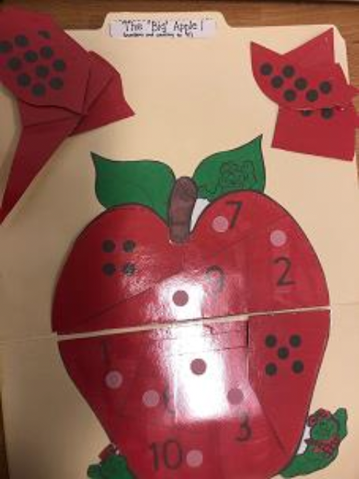
Next, teachers can use specific tasks which are also designed to observe and document children’s understanding. An example of this could be the “Big Apple – Numbers and Counting to 10” file folder game. This is a self-selected activity that can be placed on the table during center time for children to explore on their own. While they are exploring the activity, this is another great opportunity for the teacher to take pictures of the children as they explore the file folder activity. Evidence of children’s knowledge is visible as they place each piece on the correct number. After working on this activity, what are some ways the teacher could extend the children’s knowledge once they have completed the activity correctly? What are some ways the teacher could support children who may be having difficulty completing this activity correctly? These are questions teachers should consider as they guide young children’s math learning (Seefeldt, Galpher, and Stevenson-Garcia, 2012). Now let’s think about how teachers connect home and school.

Connecting Home and School
As teachers support children’s learning of the math concept – numbers and number operations, they must remember the first and most important teacher is their parents. As early childhood teachers, it is our responsibility to build strong partnerships between home and school for the betterment of children’s school readiness and success. According to Seefeldt et al. (2012) home, school, and neighborhood serve as the immediate basis for child development and learning (p. 38). There are many ways for teachers to connect home and school. The following are a few to consider as an early childhood teacher who must make the connection between home and school for the children in your classroom. First, take – home activities are a great way to reinforce concepts introduced and learned in the classroom. These can be great resources that teachers can design to align with their theme. For example, remember the “Big Apple – Numbers and Counting to 10” file folder? This is a great take – home activity that children can do to reinforce the math concept – numbers and number operations, especially because it is an activity that the children have already explored in the class and can now explore at home with parents. The great thing about experiences such as this, is that the children can teach their parents how to do activities they have explored in the classroom. Children love opportunities that allow them to become the teacher.
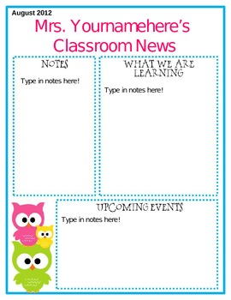
A monthly newsletter is another opportunity for teachers to share learning experiences that occur during the daily schedule. According to Herr (2012), newsletters serve as a link between home and school (p. 791). They most often include information concerning subject areas such as math. Not to mention, creating a monthly newsletter is an opportunity for teachers to list activities and resources that can be used at home to reinforce additional concepts learned in the classroom.
Depending on the monthly theme, planned field trips that parents can participate in is another way to support their child’s development and learning. For example, Mrs. Youmamehere’s theme for the week is “farm animals”. She has introduced numbers one thru 10 to her class. To support learning of this theme, she plans a field trip to a local farm. This field trip outing includes many avenues to support children’s understanding of the math concept – numbers and number operations. For instance, while visiting the farm Mrs. Youmamehere could encourage the children to count the number of chickens they see to promote the math concept numbers and number operations. As they are walking on the farm, looking at the animals, their understanding of the stages of counting develops.
From time to time, classroom volunteers are another great resource when it comes to supporting children’s development and learning. For example, reading a good book that encourages counting serves as a great way to promote math learning. As an early childhood teacher, you could solicit a parent volunteer to read the book, “Ten Black Dots” by Donald Crews. After reading the book, think about the following questions to extend the learning experience.
- What follow – up activities could you plan to reinforce what was discussed in the book?
- How could you assess children’s learning and progress after reading the book and completing the follow – up activities?
- What type of learning experiences could you create to continue the learning at home?

Conclusion
“Reciting numbers is a key step in learning math concepts (Herr, 2012, p.560). Ideally, this learning begins when children participate in well-planned early childhood settings that provide developmentally appropriate play and learning experiences (NAEYC, 2020). These experiences should help children form the math concept of counting, recognizing, and writing numerals, and using one-to-one correspondence (Herr, 2012), as they participate in developmentally appropriate math activities.
A collection of teaching strategies is needed to teach math concepts we want children to learn. We must also consider assessment tools and how we will document children’s learning. Assessing and documenting children’s mathematical knowledge, skills, and dispositions to determine their progress and learning needs is an essential part of your role as an early childhood teacher (Bullard 2014, NAEYC/NCTM 2010). This allows for planning activities and selecting materials that will scaffold children to the next math concept. According to Bullard (2014), assessment and documentation can also assist with teachers reflecting upon their own effectiveness as they evaluate their teaching strategies and styles. Another key point to remember is that there are a variety of tools that can be used when assessing children’s math skills. Most importantly, “we must assess children’s development and intentionally plan activities and interactions using developmentally appropriate materials that will challenge children to grow mathematically (Bullard, 2014, p. 268).
To conclude, we must also remember that parents are the first and most important teacher in a young child’s life. Our role as teachers is to build strong, supportive relationships that work together for children’s advancement (Seefeldt et al., 2012). This begins with educating parents about the importance of learning math during the early childhood years. This can be done through daily communication between the teacher and parents so that an appreciation of how children develop and learn is acquired (Kruse, 2005). Once this appreciation and awareness is developed, teachers can involve parents in the learning experiences by providing resources that can be used at home to foster math learning.

References

Bredekamp, S. (2014). Effective practices in early childhood education: Building a foundation 2nd

Edition. Upper Saddle River, NJ: Pearson.

Bullard, J. (2014). Creating environments for learning: Birth to eight, 2nd Edition. Upper Saddle River, NJ: Pearson.

Education, O. o. (2013, August 11). Virginia's Foundation Blocks for Early Learning: Comprehensive Standards for Four-Year-Olds. Richmond, Virginia, United States.

Eductation, V. B. (2021). Virginia's Early Learning & Development Standards; Birth - Five Learning Guidelines. Richmond, Virginia, USA.

Herr, J. (2012). Working with young children 7thEdition. Tinley Park, IL: Goodhear-Wilicox Company, Inc.

Kruse, T. S. (2005). Building a High/Scope program: Family childcare programs. Ypsilant, MI: High Scope Press.

NAEYC. (2020, April 5). 10 Effective DAP Teaching Stategies. Retrieved from National Asociation for the Education of Young Children: https://www.naeyc.org/resources/topics/dap/10-effective-dap-teaching-strategies

Seefeldt, C., Galpjer, A., & Stevenson-Garcia, J. (2012). Active experiences for active children: Mathematics 3rd Edition. Upper Saddle River, NJ: Pearson.

Tomilinson, C. A. (2022, February 11). Reading Rockets. Retrieved from What Is Differentiated Instruction?: https://www.readingrockets.org/article/what-differentiated-instruction

